**VASE LINE**

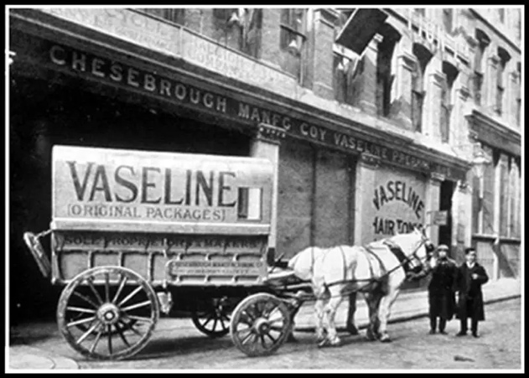Vaseline, also known as petroleum jelly, is a versatile and widely used product that has been around for over a century. The invention of Vaseline is credited to Robert Chesebrough, a chemist and inventor who developed the product in the late 19th century. In this essay, we will explore the history of Vaseline, the life of Robert Chesebrough, and the impact of his invention on society.

**INVENTION OF VASELINE – BACKGROUND**

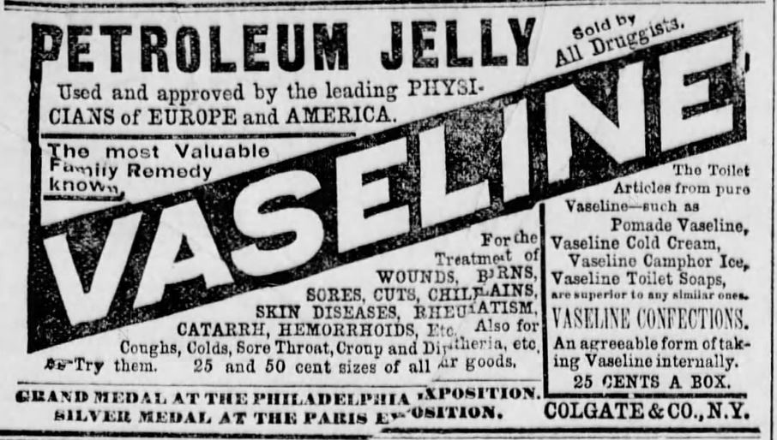The story of Vaseline begins in the 1870s when Robert Chesebrough was working as a young chemist in Brooklyn, New York. Chesebrough had a keen interest in the properties of oil and its byproducts, and he was always on the lookout for new materials that could be used for industrial or medicinal purposes. One day, he heard about a substance called "rod wax" that oil rig workers were using to heal their skin injuries. Intrigued by the claims of its healing properties, Chesebrough travelled to the oil fields in Titusville, Pennsylvania, to investigate.

What he found was a substance that was thick and sticky, similar to tar. The workers would rub it on their skin to help heal cuts, burns, and other injuries. Chesebrough was fascinated by this substance and began experimenting with it. He would boil it down to remove impurities, filter it to remove any remaining sediment, and then refine it further by treating it with various chemicals. After many months of experimentation, Chesebrough developed a clear, odourless jelly that he named "Vaseline."

Chesebrough was convinced that Vaseline had numerous uses and set out to promote it. He travelled around the country, demonstrating its many applications, and began selling it door-to-door. He established the Chesebrough Manufacturing Company in 1875 to produce and market Vaseline, and the product quickly became popular.

**USES OF VASELINE - NEED**

* Moisturizing skin: Vaseline can be used as a moisturizer to help hydrate and soothe dry skin. It forms a protective barrier on the skin that helps to prevent moisture loss and keeps the skin hydrated.
* 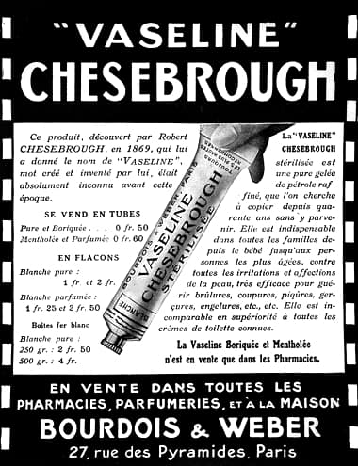Treating chapped lips: Vaseline can be used to moisturize and protect dry, chapped lips. It can be applied as a lip balm to help prevent further drying and cracking.
* Healing minor cuts and burns: Vaseline can be applied to minor cuts and burns to help protect the wound and promote healing.
* Preventing diaper rash: Vaseline can be applied to a baby's bottom to create a protective barrier and prevent diaper rash.
* Removing makeup: Vaseline can be used as a gentle and effective makeup remover. It can be applied to the skin with a cotton ball or swab and then wiped away with a clean cloth.
* Lubricating hinges and locks: Vaseline can be used to lubricate hinges, locks, and other metal parts. It helps to prevent rust and corrosion and keeps moving parts working smoothly.
* Preventing hair dye from staining the skin: Vaseline can be applied to the hairline and other areas around the face before colouring hair to help prevent the dye from staining the skin.
* Taming flyaway hair: Vaseline can be used as a hair styling product to help smooth down flyaway hair and add shine.

**ABOUT ROBERT CHESEBROUGH**

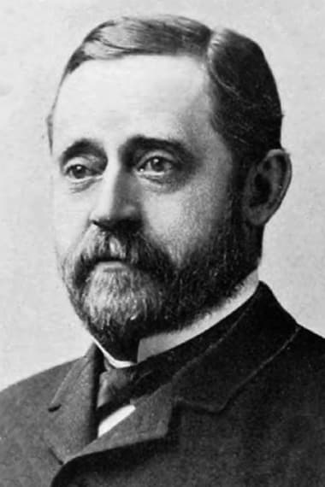The story of Vaseline begins in the 1870s when Robert Chesebrough was working as a young chemist in Brooklyn, New York. Chesebrough had a keen interest in the properties of oil and its by-products, and he was always on the lookout for new materials that could be used for industrial or medicinal purposes. One day, he heard about a substance called "rod wax" that oil rig workers were using to heal their skin injuries. Intrigued by the claims of its healing properties, Chesebrough travelled to the oil fields in Titusville, Pennsylvania, to investigate.

What he found was a substance that was thick and sticky, similar to tar. The workers would rub it on their skin to help heal cuts, burns, and other injuries. Chesebrough was fascinated by this substance and began experimenting with it. He would boil it down to remove impurities, filter it to remove any remaining sediment, and then refine it further by treating it with various chemicals. After many months of experimentation, Chesebrough developed a clear, odourless jelly that he named "Vaseline."

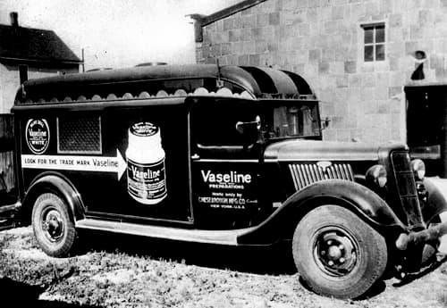Chesebrough was convinced that Vaseline had numerous uses and set out to promote it. He travelled around the country, demonstrating its many applications, and began selling it door-to-door. He established the Chesebrough Manufacturing Company in 1875 to produce and market Vaseline, and the product quickly became popular. Chesebrough is awarded the Franklin Institute's Elliott Cresson Medal for his contributions to the development of petroleum products.

**SHIVANG GULATI**

**220905264**

**PE - 19**